Week 10 Lecture 1

Previous Lecture
- Pointers & Linked List

Today’s Lecture
- Stack

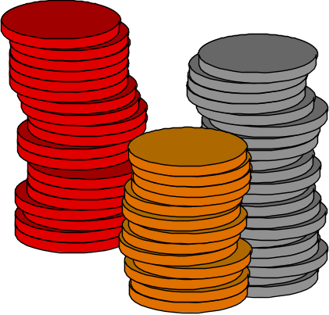

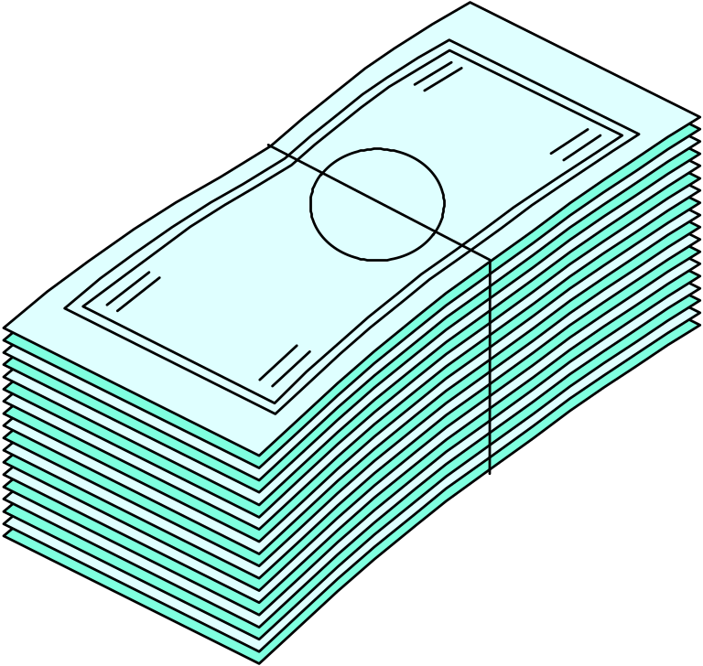Stacks of Coins and Bills

What is a Stack?

- Logical (or ADT) level: A stack is an ordered group of homogeneous items (elements), in which the removal and addition of stack items can take place only at the top of the stack.

- A stack is a LIFO “last in, first out” structure.
?

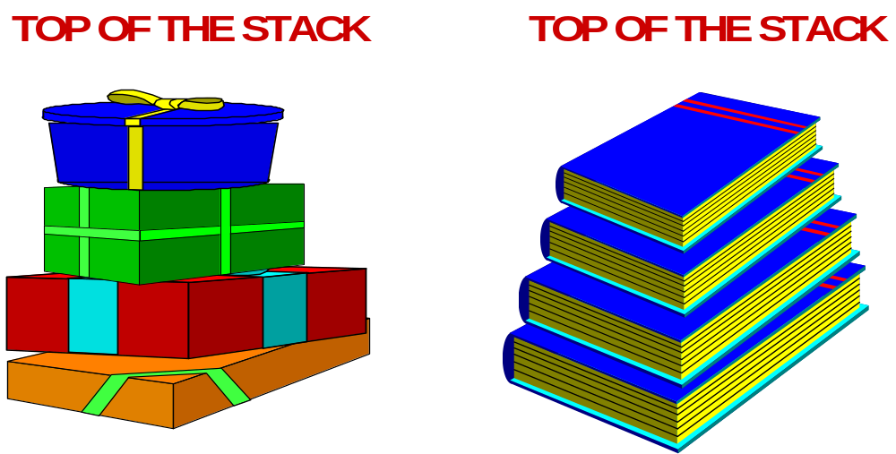
Stacks of Boxes and Books
Stack ADT Operations

- MakeEmpty -- Sets stack to an empty state.
- IsEmpty -- Determines whether the stack is currently empty.

- IsFull -- Determines whether the stack is currently full.
- Push (ItemType newItem) -- Throws exception if stack is full; otherwise adds newItem to the top of the stack.

- Pop (ItemType& item) -- Throws exception if stack is empty; otherwise removes the item at the top of the stack and returns it in item.
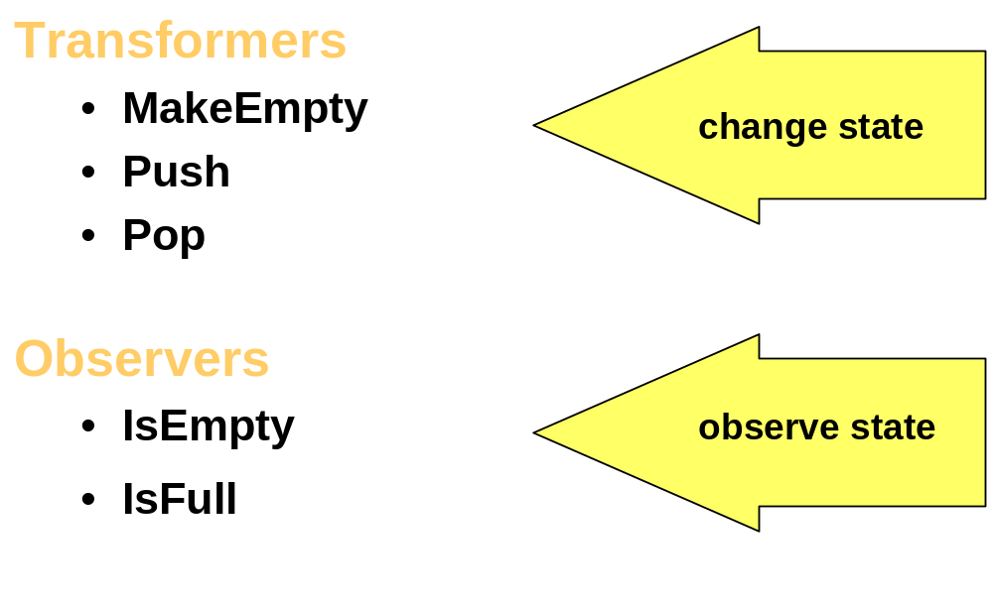
ADT Stack Operations

//--------------------------------------------------------
// SPECIFICATION FILE (stack.h)
//---------------------------------------------------------
#include "ItemType.h" // for MAX_ITEMS and
// class ItemType definition
class StackType
{
public:
StackType( );
// Default constructor.
// POST: Stack is created and empty.

void MakeEmpty( );
// PRE: None.
// POST: Stack is empty.

bool IsEmpty( ) const;
// PRE: Stack has been initialized.
// POST: Function value = (stack is empty)

// SPECIFICATION FILE continued (Stack.h)

bool IsFull( ) const;
// PRE: Stack has been initialized.
// POST: Function value = (stack is full)
void Push( ItemType newItem );
// PRE: Stack has been initialized and is not full.
// POST: If stack is full, an exception is thrown;
// otherwise newItem is at the top of the
// stack.
void Pop( ItemType& item );
// PRE: Stack has been initialized and is not empty.
// POST: If stack if empty, an exception is thrown;
// otherwise top element has been removed from
// stack.item is a copy of removed element.
private:
int top;
ItemType items[MAX_ITEMS]; // array of ItemType
};
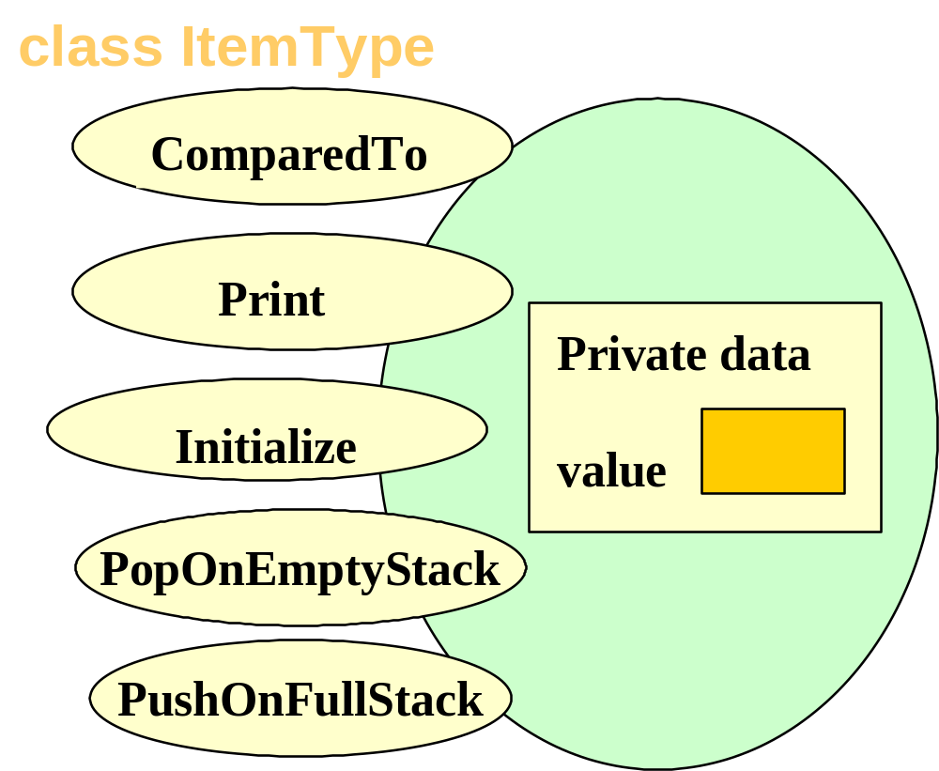
ItemType Class Interface Diagram

//-------------------------------------------------------
// IMPLEMENTATION FILE (Stack.cpp)
//------------------------------------------------------
// Private data members of class:
// int top;
// ItemType items[MAX_ITEMS];
//-------------------------------------------------------
#include “ItemType.h”

StackType::StackType( )
//------------------------------------------------
// Default Constructor
//------------------------------------------------
{
top = -1;
}

// IMPLEMENTATION FILE continued (Stack.cpp)
//----------------------------------------------------------

void StackType::MakeEmpty( )
//---------------------------------------------------
// PRE: None.
// POST: Stack is empty.
//---------------------------------------------------
{
top = -1;
}

// IMPLEMENTATION FILE continued (Stack.cpp)
//----------------------------------------------------------

bool StackType::IsEmpty( ) const
//---------------------------------------------------
// PRE: Stack has been initialized.
// POST: Function value = (stack is empty)
//---------------------------------------------------
{
return ( top == -1 );
}

bool StackType::IsFull( ) const
//---------------------------------------------------
// PRE: Stack has been initialized.
// POST: Function value = (stack is full)
//---------------------------------------------------
{
return ( top == MAX_ITEMS-1 );
}

// IMPLEMENTATION FILE continued (Stack.cpp)
//-------------------------------------------------------------

void StackType::Push ( ItemType newItem )
//------------------------------------------------------
// PRE: Stack has been initialized and is not full.
// POST: newItem is at the top of the stack.
//------------------------------------------------------
{
if (IsFull())
throw PushOnFullStack();
top++;
items[top] = newItem;
}
// IMPLEMENTATION FILE continued (Stack.cpp)
//-------------------------------------------------------------
void StackType::Pop ( ItemType& item )
//------------------------------------------------------
// PRE: Stack has been initialized and is not empty.
// POST: Top element has been removed from stack.
// item is a copy of removed element.
//------------------------------------------------------
{
if (IsEmpty())
throw PopOnEmptyStack();
item = items[top];
top--;
}
Class Interface Diagram
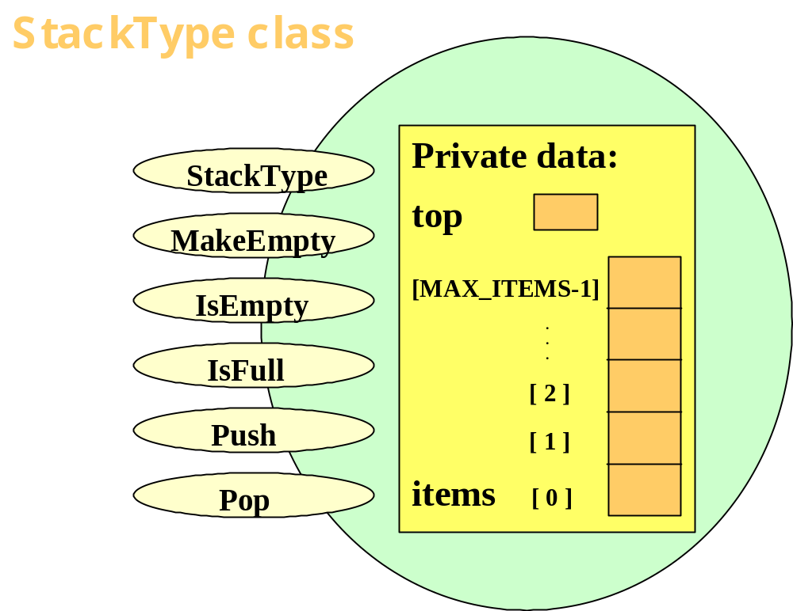

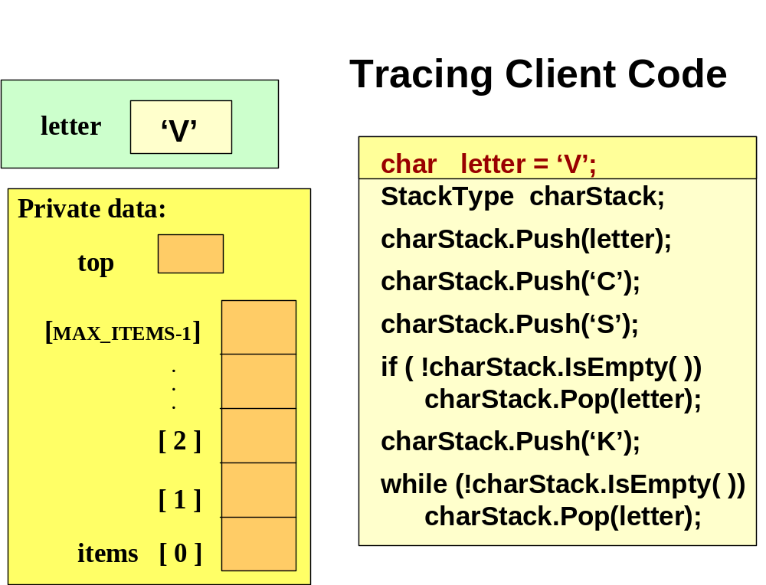
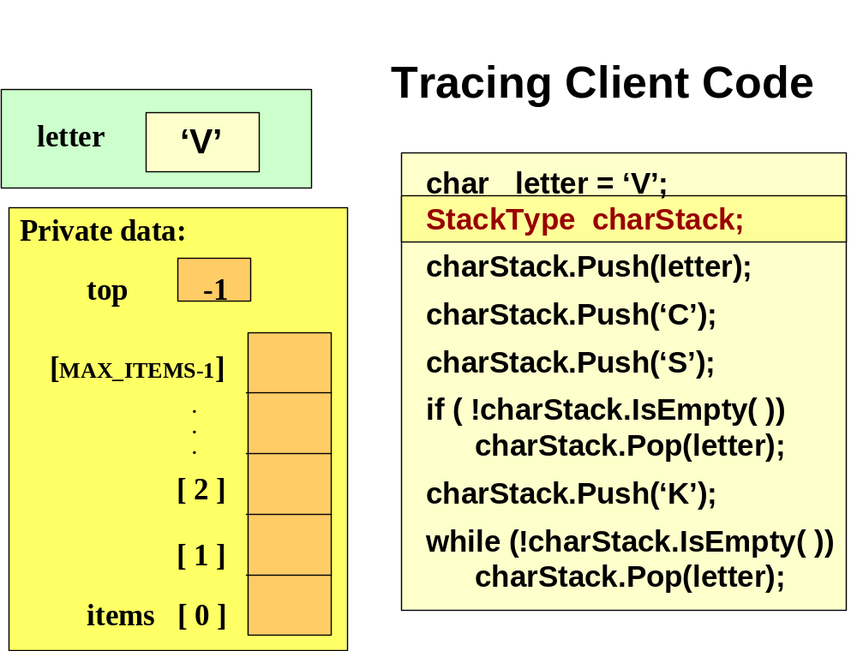
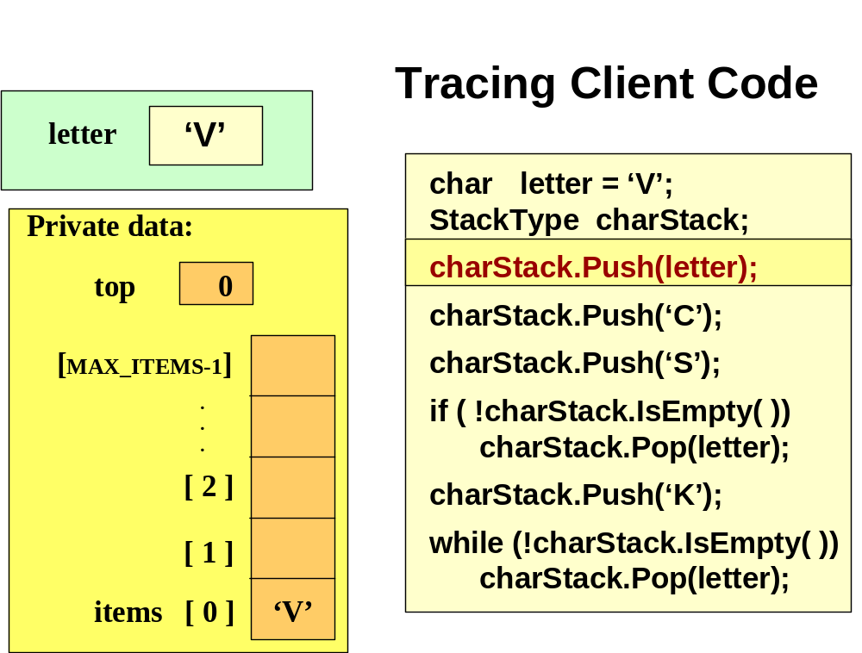
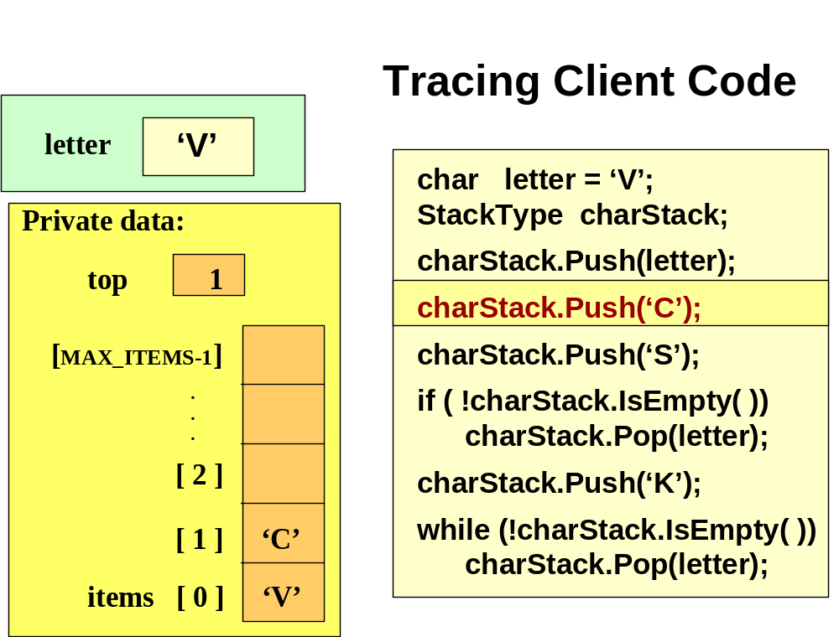
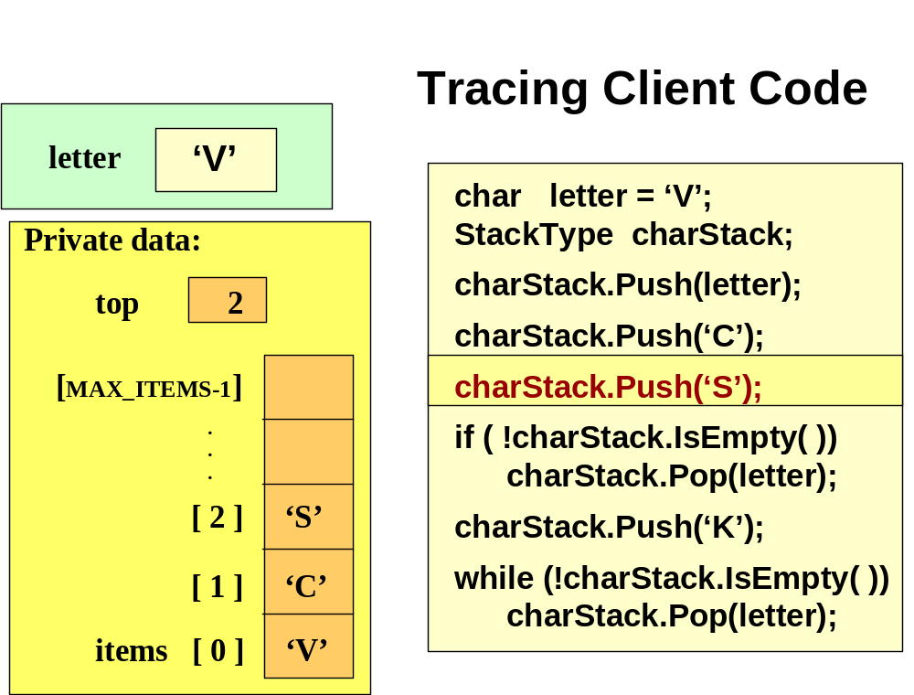
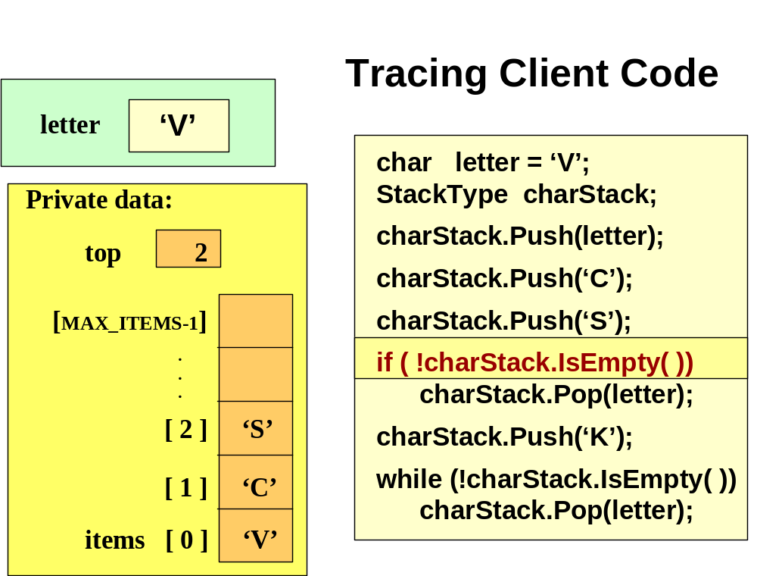
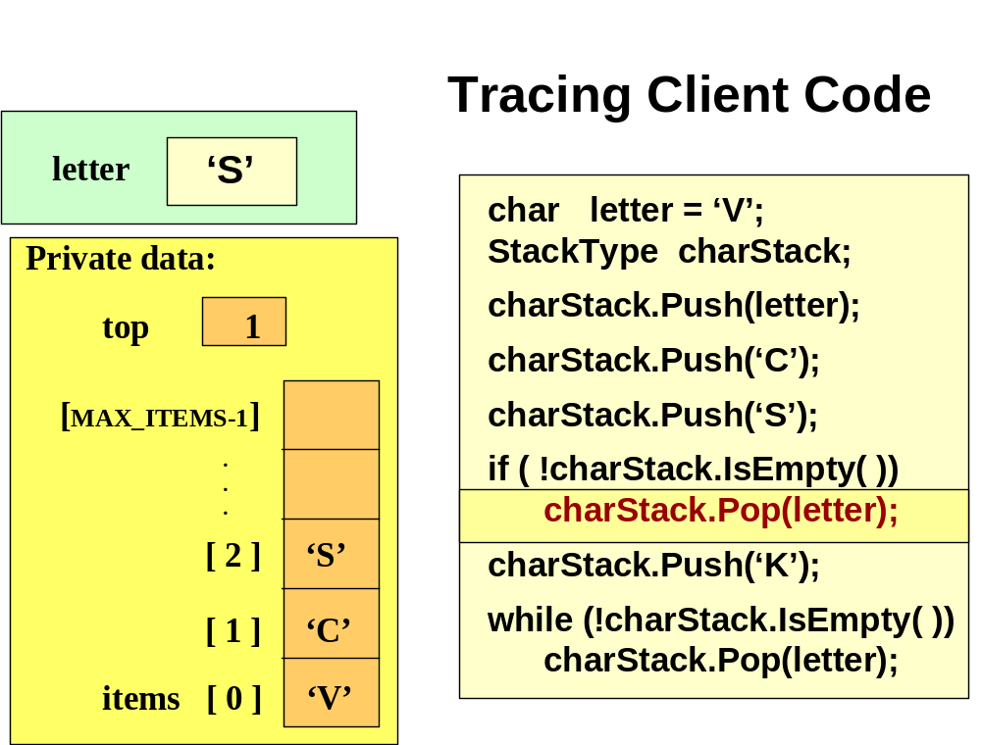
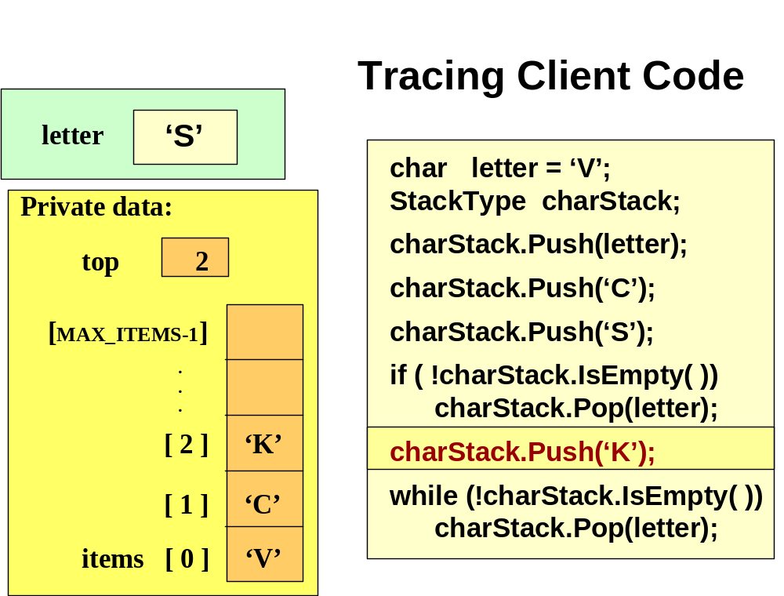
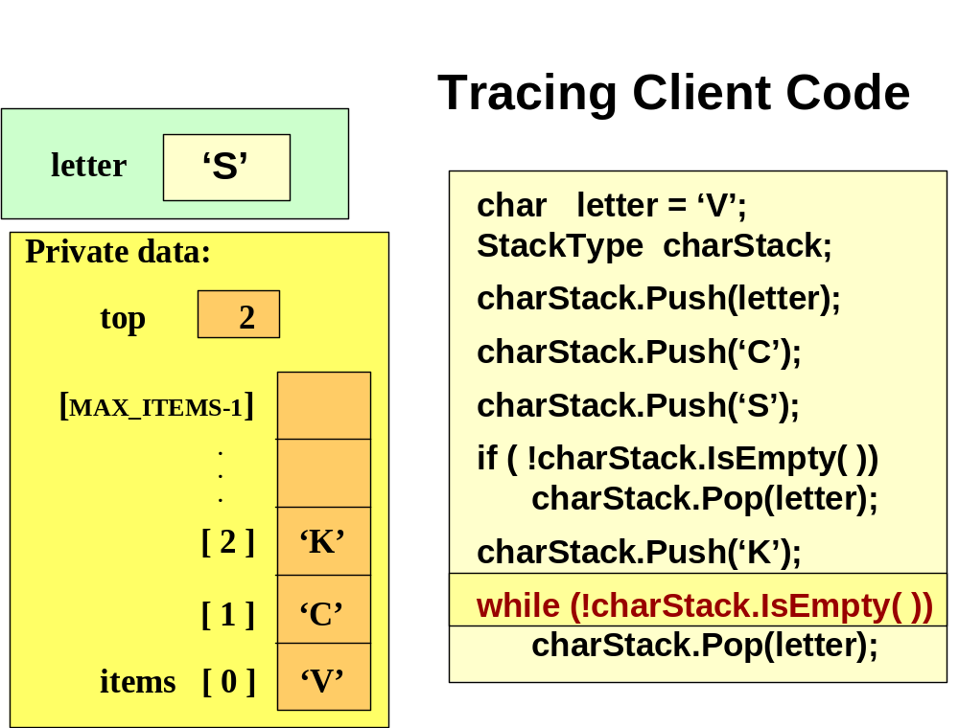
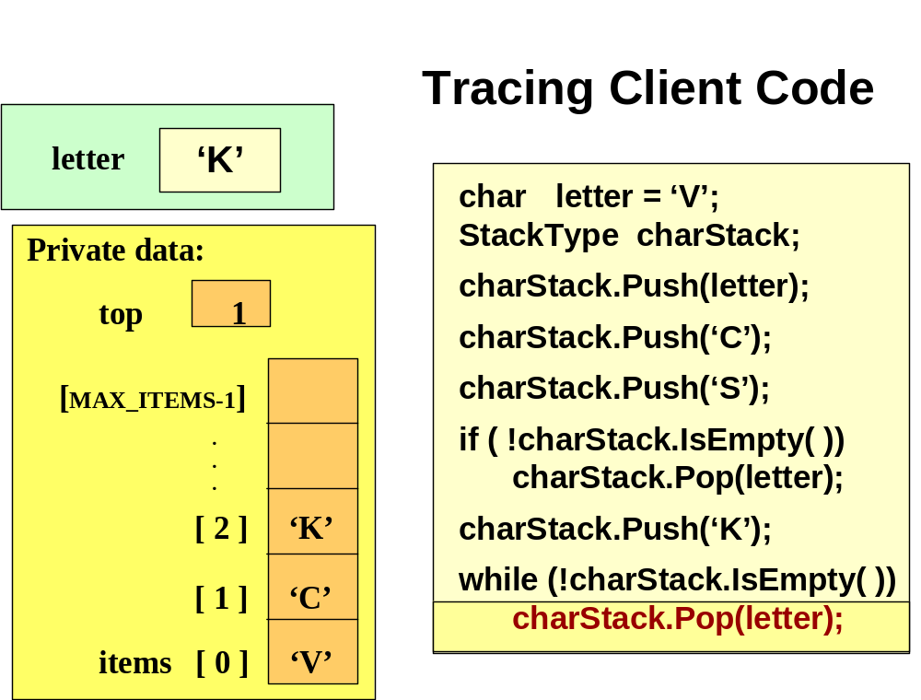
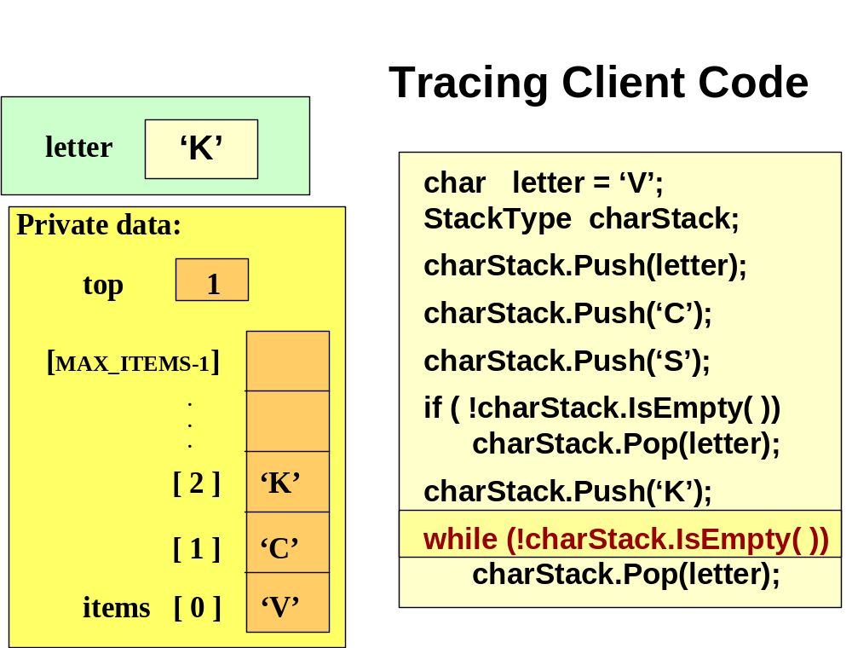
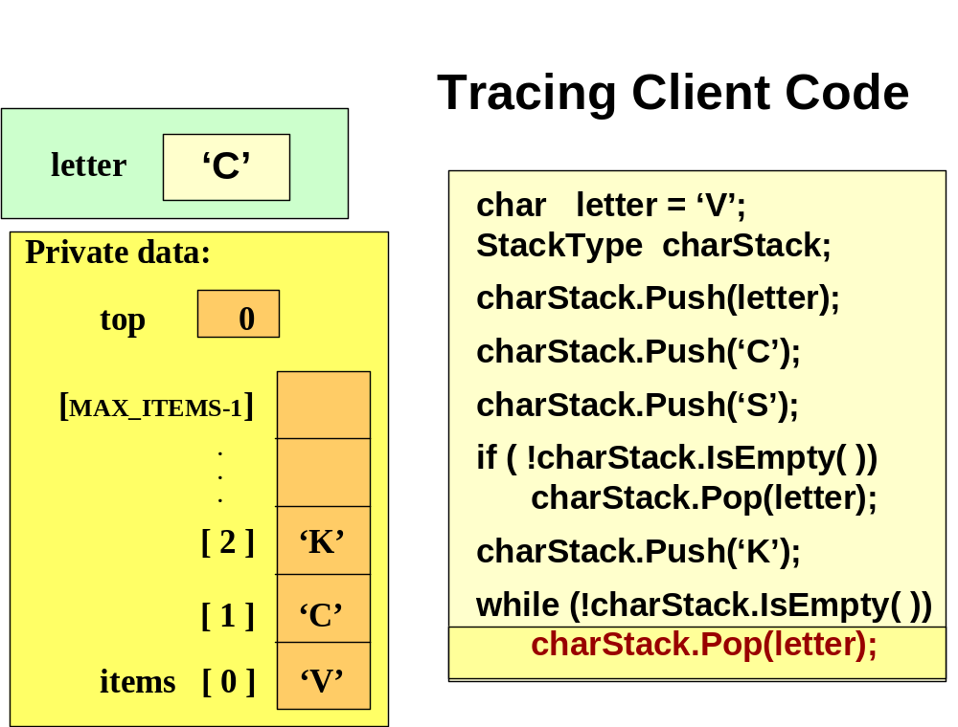
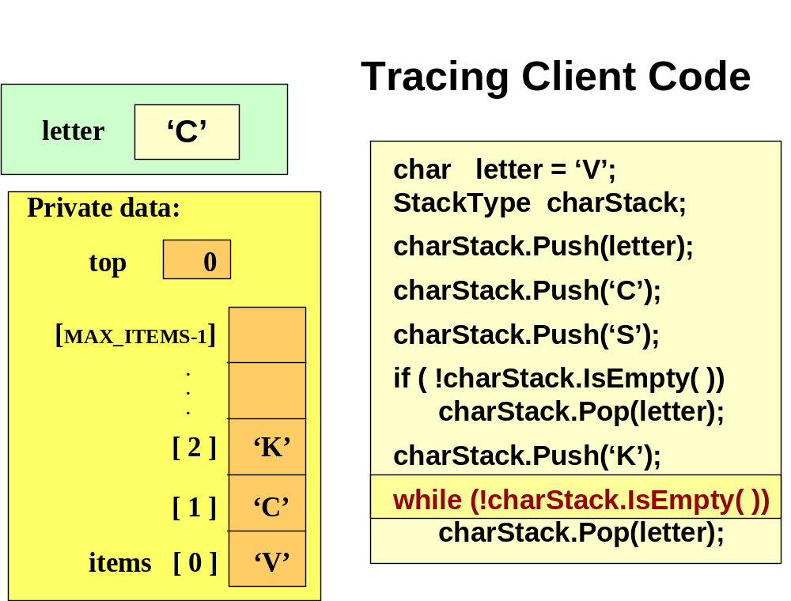
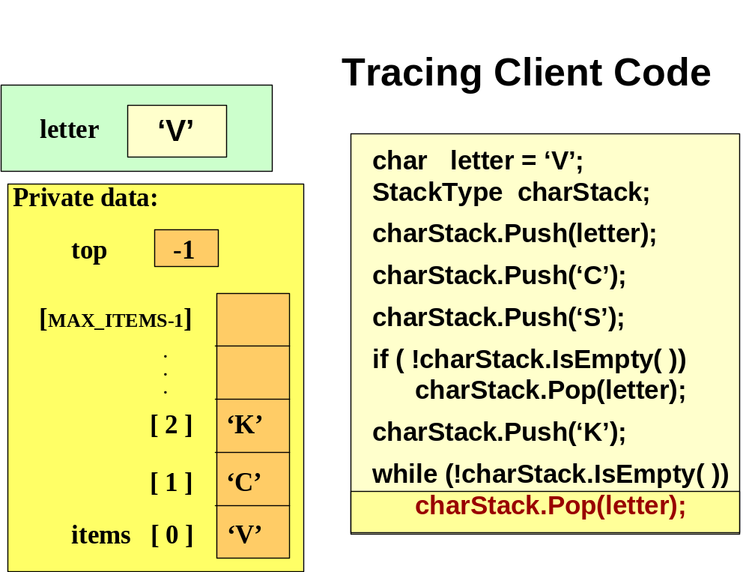
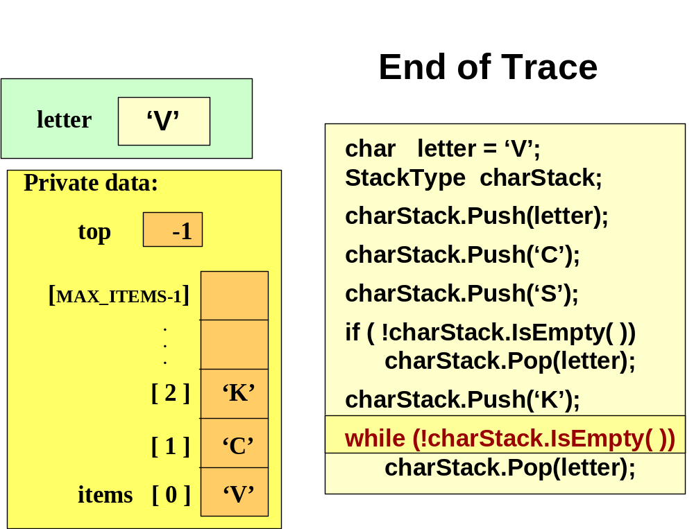
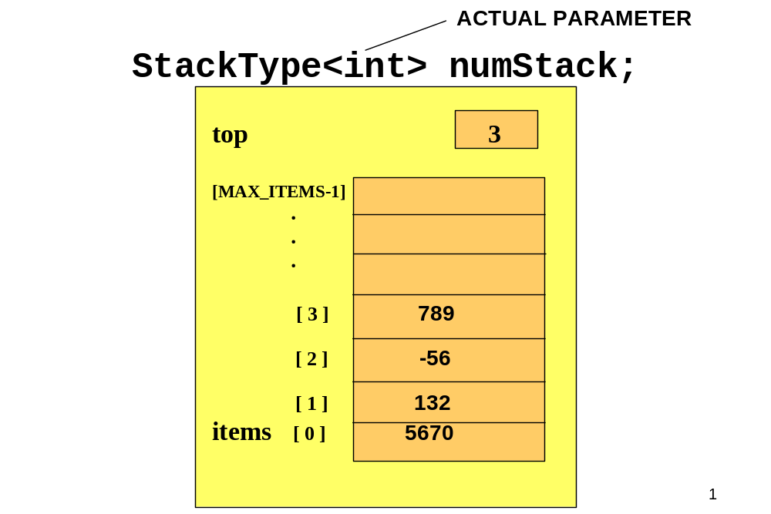
Template Implementation of Stack
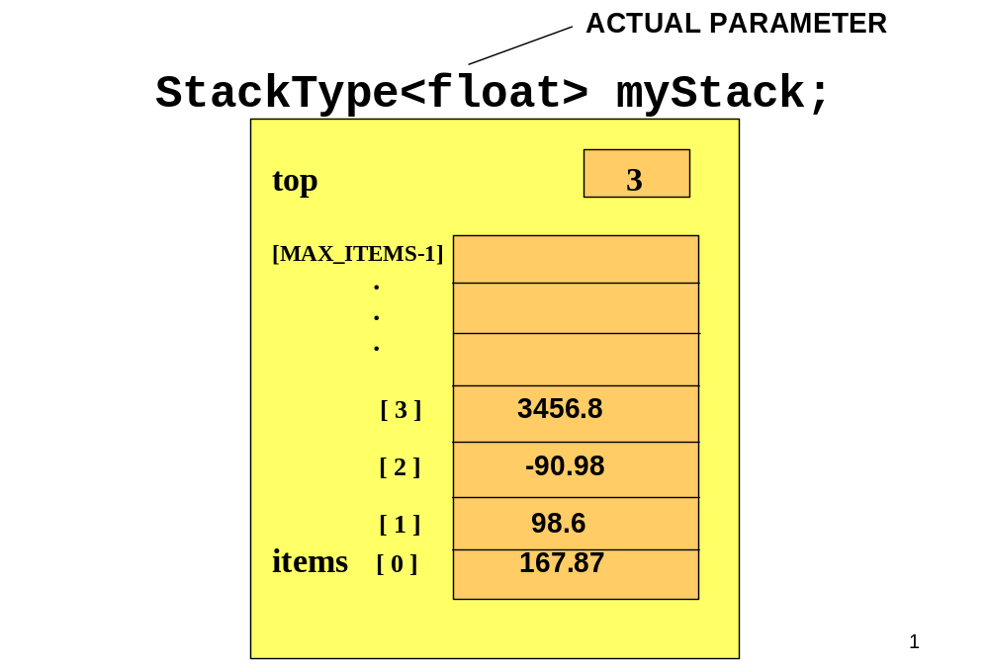
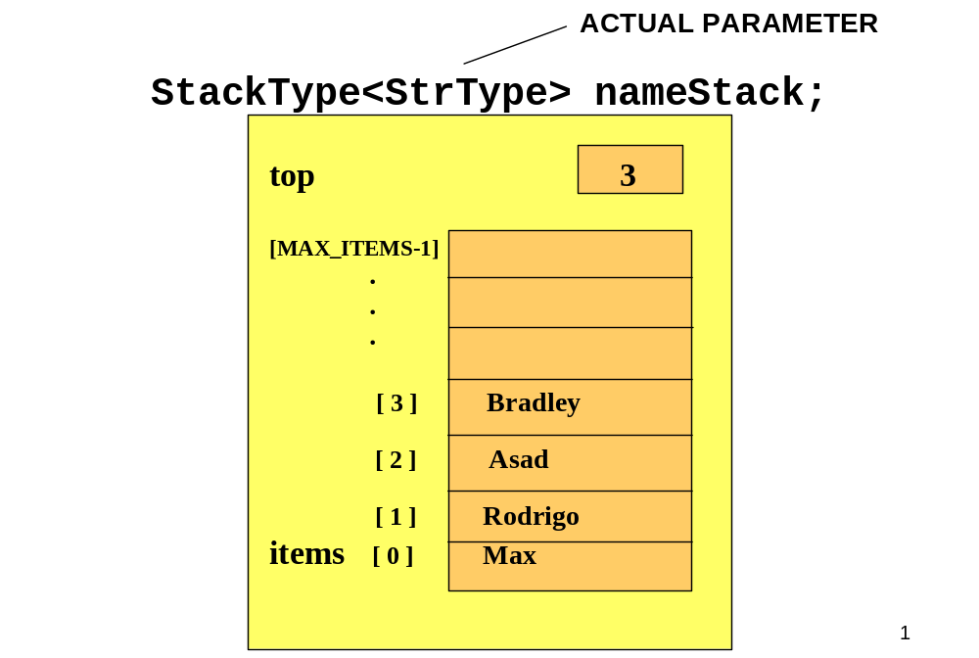
//--------------------------------------------------------
// CLASS TEMPLATE DEFINITION
//--------------------------------------------------------
#include "ItemType.h" // for MAX_ITEMS and ItemTyp
template<class ItemType> // formal parameter list
class StackType
{
public:
StackType( );
void MakeEmpty( );
bool IsEmpty( ) const;
bool IsFull( ) const;
void Push( ItemType item );
void Pop( ItemType& item );

private:
int top;
ItemType items[MAX_ITEMS];
};
//--------------------------------------------------------
// SAMPLE CLASS MEMBER FUNCTIONS
//--------------------------------------------------------

template<class ItemType> // formal parameter list
StackType<ItemType>::StackType( )
{
top = -1;
}
template<class ItemType> // formal parameter list
void StackType<ItemType>::Push ( ItemType newItem )
{
if (IsFull())
throw PushOnFullStack();
top++;
items[top] = newItem; // STATIC ARRAY IMPLEMENTATION
}
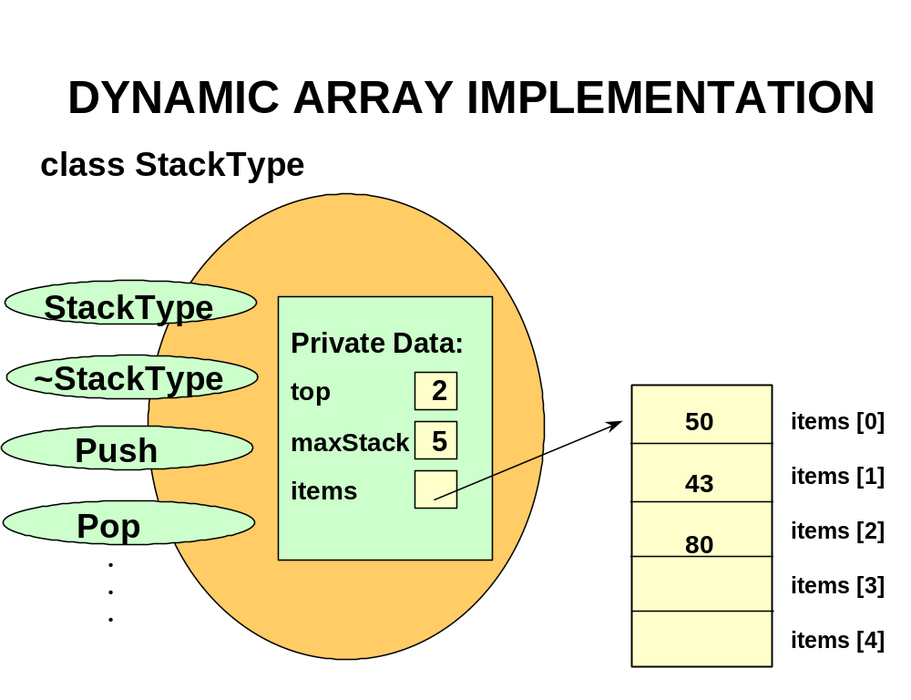
//--------------------------------------------------------
// CLASS TEMPLATE DEFINITION AND MEMBER FUNCTIONS

#include "ItemType.h" // for ItemType
template<class ItemType>
class StackType
{
public:
StackType( );
StackType( int max ); // PARAMETERIZED CONSTRUCTOR
~StackType( ) ; // DESTRUCTOR
. . .
bool IsFull( ) const;
void Push( ItemType item );
void Pop( ItemType& item );
private:
int top;
int maxStack;
ItemType* items; // DYNAMIC ARRAY IMPLEMENTATION
};
//--------------------------------------------------------
// CLASS TEMPLATE DEFINITION AND MEMBER FUNCTIONS cont’d
//--------------------------------------------------------

template<class ItemType>
StackType<ItemType>::StackType( ) //DEFAULT CONSTRUCTOR
{
maxStack = 500;
top = -1;
items = new ItemType[500]; // dynamically allocates array
}

template<class ItemType>
StackType<ItemType>::StackType( int max ) // PARAMETERIZED
{
maxStack = max;
top = -1;
items = new ItemType[max]; // dynamically allocates array
}
//--------------------------------------------------------
// CLASS TEMPLATE DEFINITION AND MEMBER FUNCTIONS cont’d
//--------------------------------------------------------

template<class ItemType>
StackType<ItemType>::~StackType( )
{
delete [ ] items; // deallocates array
}

.
.
.

template<class ItemType>
bool StackType<ItemType>::IsFull( )

{
return (top == maxStack - 1)
}

Today’s Lecture

- Stack

Next Lecture

- Queue

